Scenario:

1. Enter transaction code VX11.

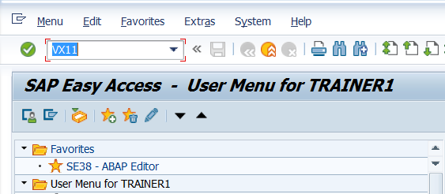

1. Enter the details as shown below and press enter.  
   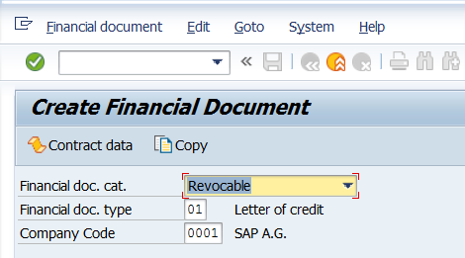
2. Observe the screen below.

Steps for Screen Exit.

1. On the above screen , check System Status

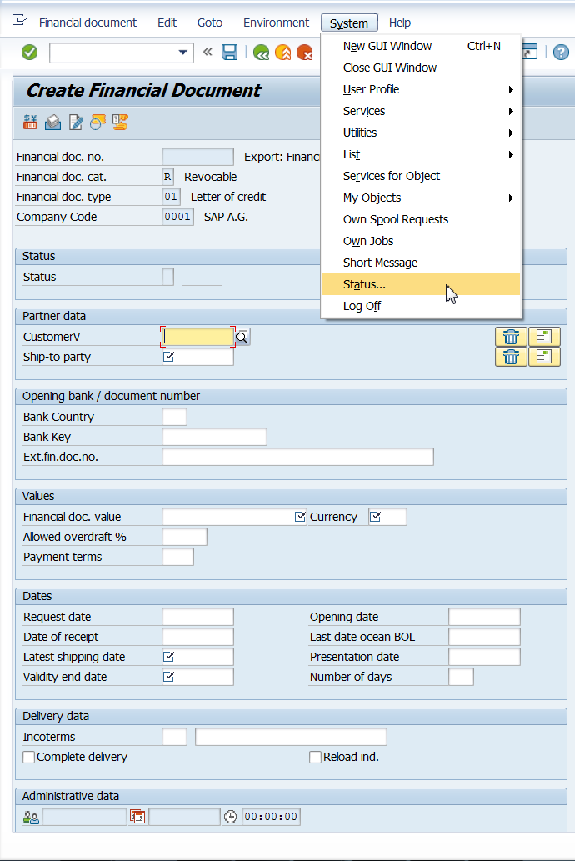

1. Double click on the program name SAPMV86E and it takes us to the corresponding program in SE38..

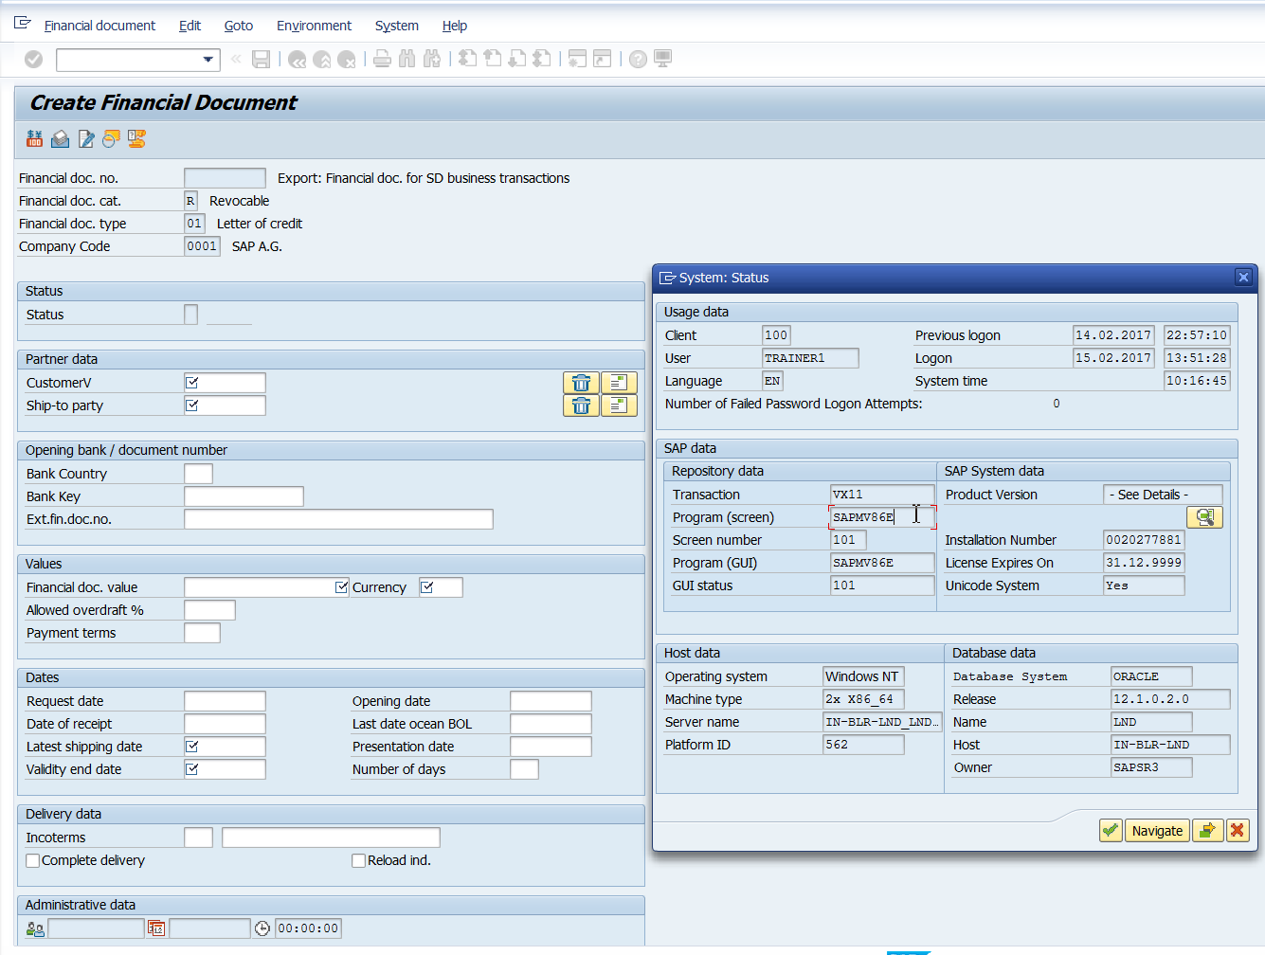

1. Check the attributes of the program. Goto Attributes in the Menu. Observe the package name.

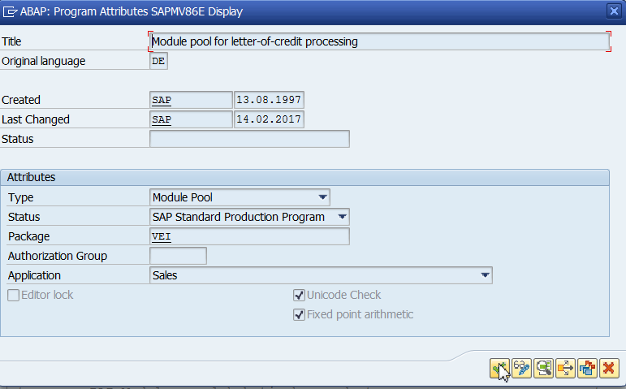

1. Go to SMOD.

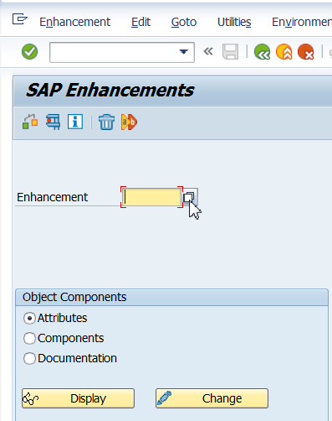

1. Click on Information System.

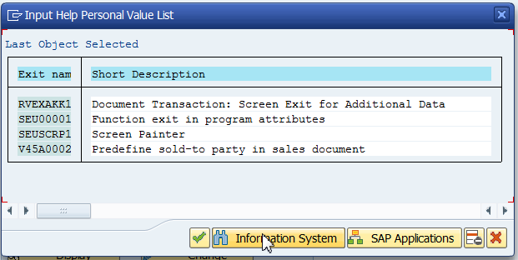

1. Enter package name and click continue.

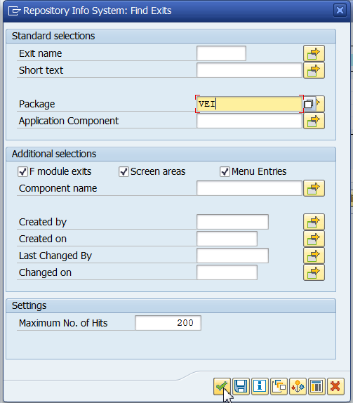

1. Observe the exits.

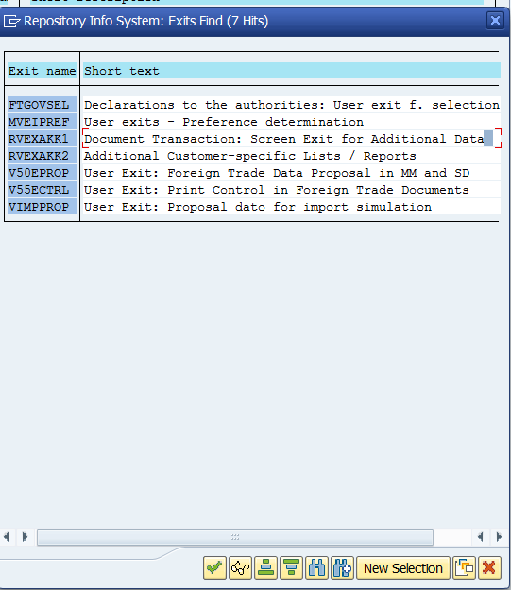

1. RVEXAKK1 is the exit we need to modify.
2. Go to CMOD

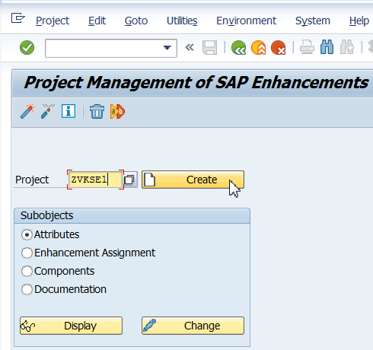

1. Click on Enhancement assignments.

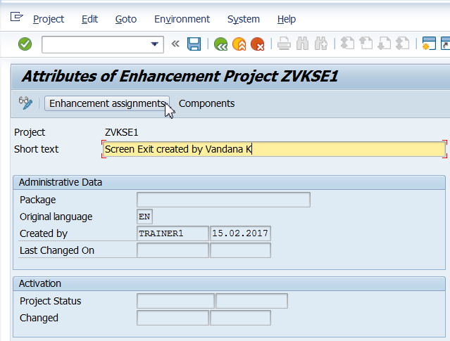

1. Save it in a package or as a local object.
2. Enter the enhancement name as shown below and press enter. The text is automatically displayed. Click on components.

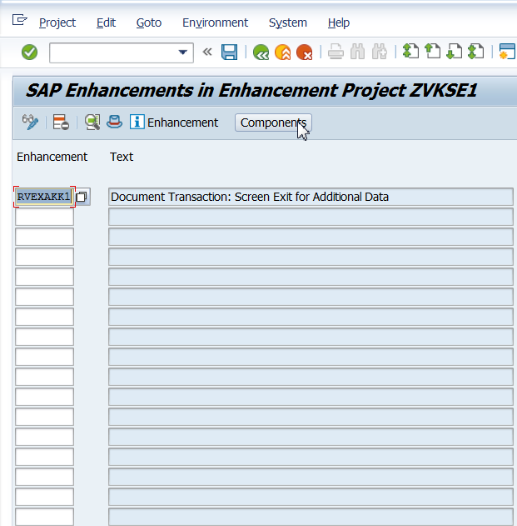

1. Double Click on the selected exit.

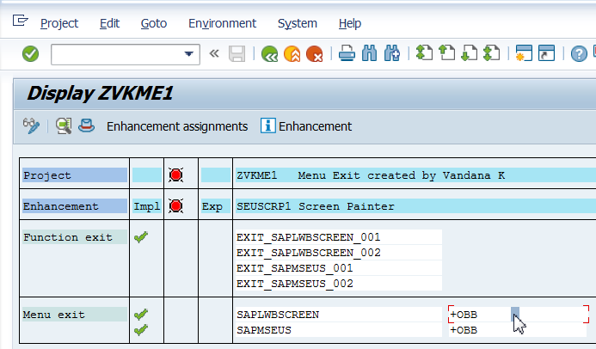

1. Enter Function Text as shown below.

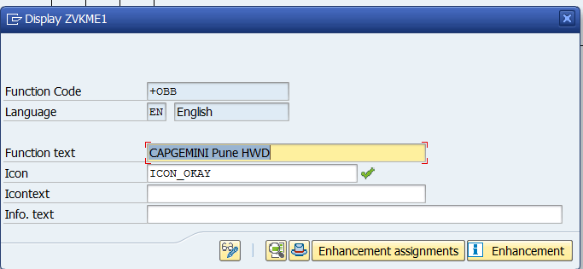

1. Click on Change.

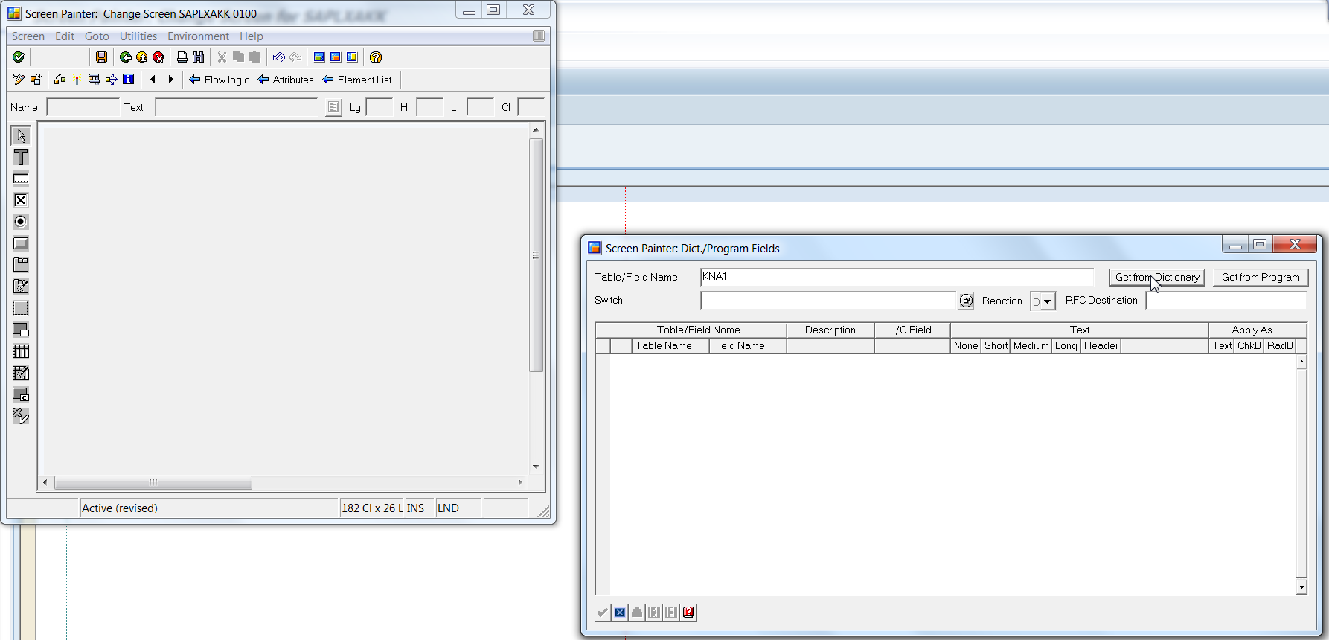

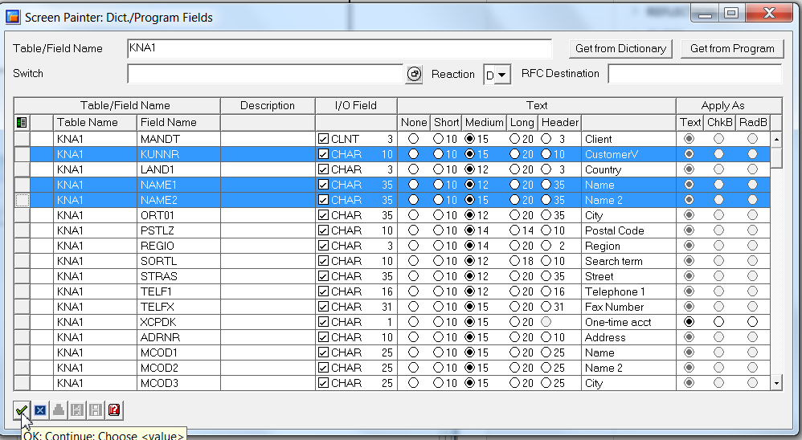

1. Save and activate.

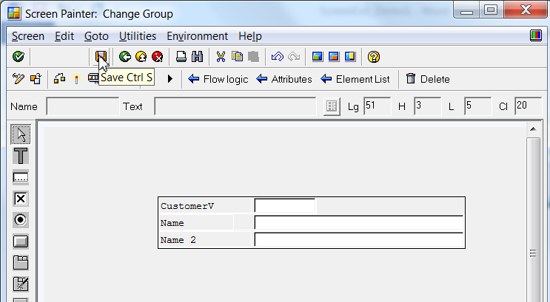

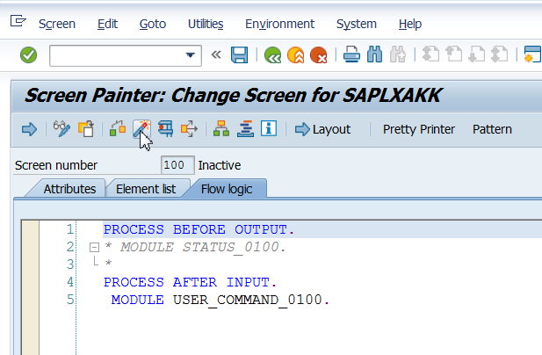

1. Save. Activate. Press F3. Till you reach the below screen and ensure that the exit is activated.

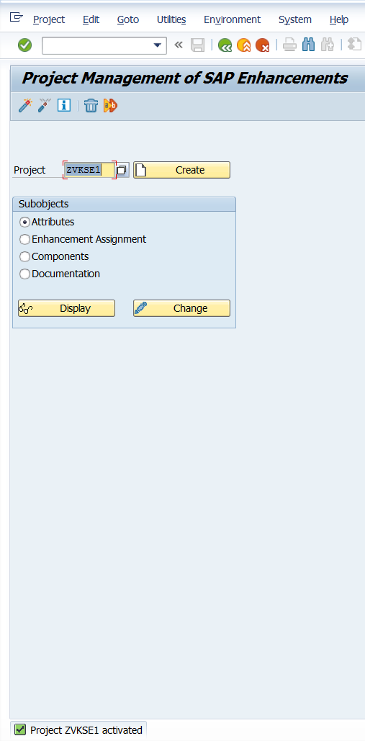

1. Go to VVX11 and enter details as shown below and press enter.

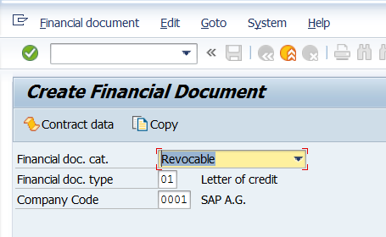

1. Scroll down and observe additional data.

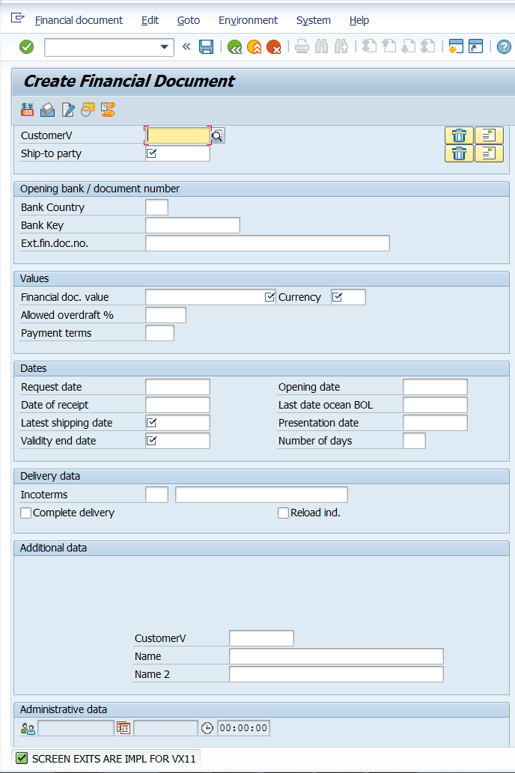

If the screen exit is deactivated, the additional data is not visible. Some coding can be done in function exits for the function a